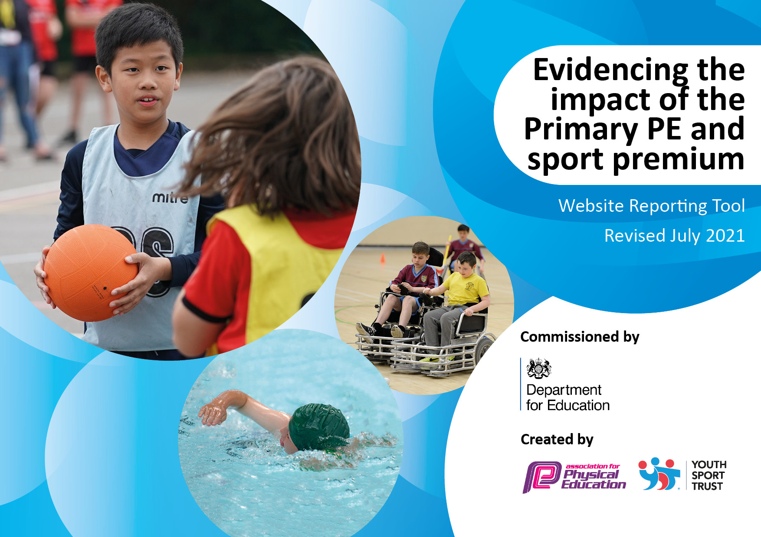
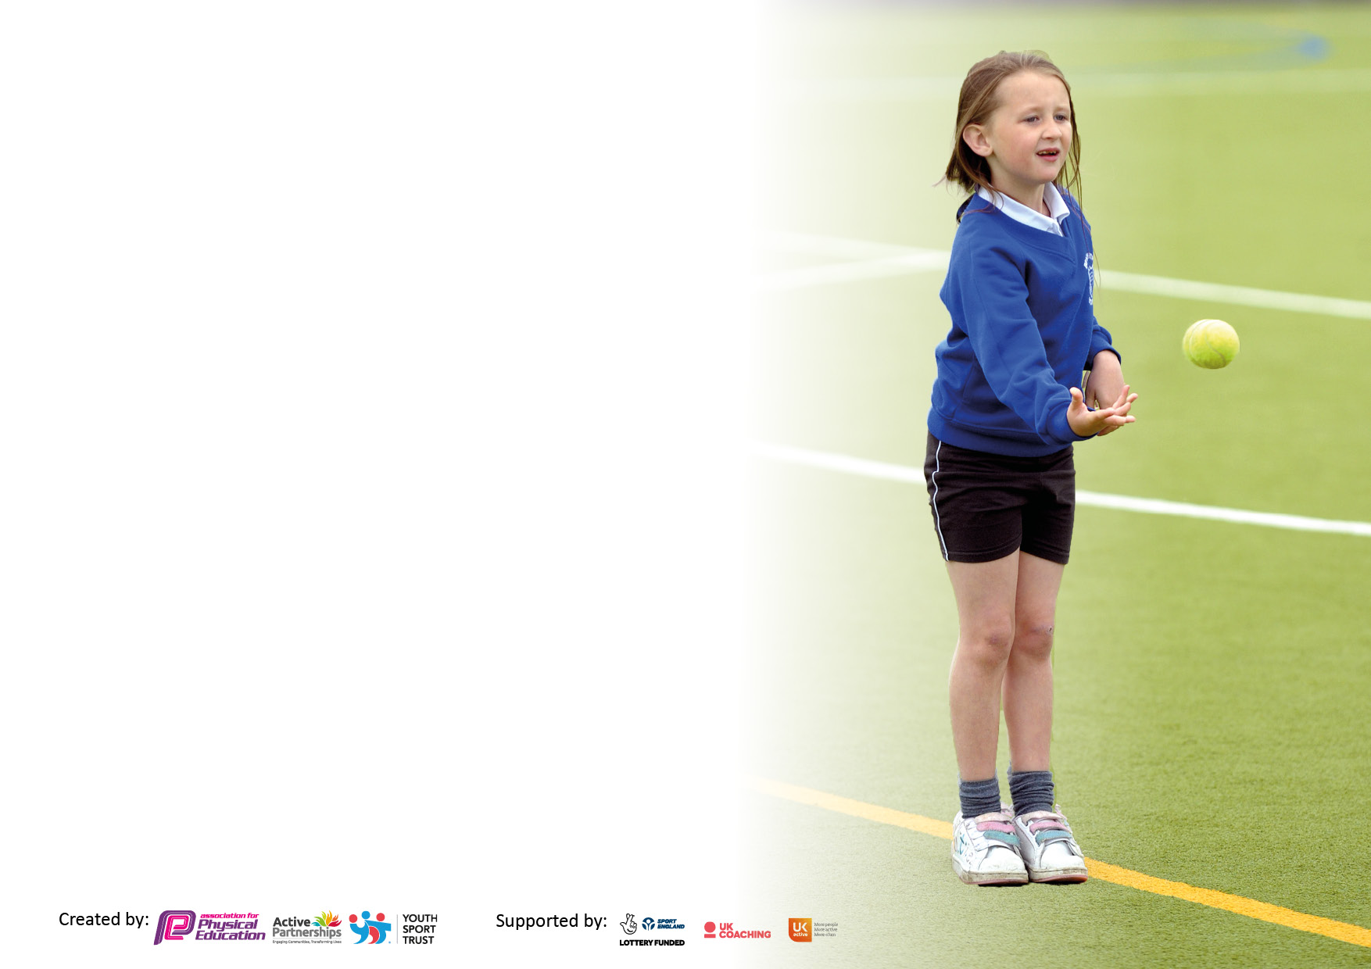

It is important that your grant is used effectively and based on school need. The Education Inspection Framework makes clear there will be a focus on ‘whether leaders and those responsible for governors all understand their respective roles and perform these in a way that enhances the effectiveness of the school’.

Under the Quality of Education Ofsted inspectors consider:
Intent - Curriculum design, coverage and appropriateness
Implementation - Curriculum delivery, Teaching (pedagogy) and Assessment
Impact - Attainment and progress

To assist schools with common transferable language this template has been developed to utilise the same three headings which should make your plans easily transferable between working documents.

Schools must use the funding to make additional and sustainable improvements to the quality of Physical Education, School Sport and Physical Activity (PESSPA) they offer. This means that you should use the Primary PE and sport premium to:

- Develop or add to the PESSPA activities that your school already offer
- Build capacity and capability within the school to ensure that improvements made now will benefit pupils joining the school in future years
- The Primary PE and sport premium should not be used to fund capital spend projects; the school’s budget should fund these.

Pleasevisitgov.ukfortherevisedDfEguidanceincludingthe5keyindicatorsacrosswhichschoolsshoulddemonstrate animprovement.Thisdocumentwillhelpyoutoreviewyourprovisionandtoreportyourspend.DfEencouragesschools to use this template as an effective way of meeting the reporting requirements of the Primary PE and sport premium.

We recommend you start by reflecting on the impact of current provision and reviewing the previous spend.

Schools are required to publish details of how they spend this funding, including any under-spend from 2019/2020, as well as on the impact it has on pupils’ PE and sport participation and attainment. All funding must be spent by 31st July 2022.

We recommend regularly updating the table and publishing it on your website throughout the year. This evidences your ongoing self-evaluation of how you are using the funding to secure maximum, sustainable impact. Final copy must be posted on your website by the end of the academic year and no later than the 31st July 2021. To see an example of how to complete the table please click HERE.

Details with regard to funding
Please complete the table below.

Total amount carried over from 2019/20 | £8900
Total amount allocated for 2020/21 | £17800
How much (if any) do you intend to carry over from this total fund into 2021/22? | £12274.88
Total amount allocated for 2021/22 | £17800
Total amount of funding for 2021/22. To be spent and reported on by 31st July 2022. | £30074.88
Swimming Data
Please report on your Swimming Data below.

Meeting national curriculum requirements for swimming and water safety.

N.B. Complete this section to your best ability. For example you might have practised safe self-rescue techniques on dry land which you can then transfer to the pool when school swimming restarts.
Due to exceptional circumstances priority should be given to ensuring that pupils can perform safe self rescue even if they do not fully meet the first two requirements of the NC programme of study
What percentage of your current Year 6 cohort swim competently, confidently and proficiently over a distance of at least 25 metres?  N.B. Even though your pupils may swim in another year please report on their attainment on leaving primary school at the end of the summer term 2020.  Please see note above | 47%
What percentage of your current Year 6 cohort use a range of strokes effectively [for example, front crawl, backstroke and breaststroke]?  Please see note above | 47%
What percentage of your current Year 6 cohort perform safe self-rescue in different water-based situations? | 20%
Schools can choose to use the Primary PE and sport premium to provide additional provision for swimming but this must be for activity over and above the national curriculum requirements. Have you used it in this way? | Yes/No

Action Plan and Budget Tracking
Capture your intended annual spend against the 5 key indicators. Clarify the success criteria and evidence of impact that you intend to measure to evaluate for pupils today and for the future.

Academic Year: 2021/22 | Total fund allocated: £30074.88 | Date Updated:28.6.22
Key indicator 1: The engagement of all pupils in regular physical activity – Chief Medical Officers guidelines recommend that primary school pupils undertake at least 30 minutes of physical activity a day in school |  |  |  | Percentage of total allocation:
 |  |  |  | 48.9%
Intent | Implementation |  | Impact
Your school focus should be clear what you want the pupils to know and be able to do and about  what they need to learn and to  consolidate through practice: | Make sure your actions to achieve are linked to your intentions: | Funding allocated: | Evidence of impact: what do pupils now know and what can they now do? What has changed?: | Sustainability and suggested next steps:
To ensure all children have access to high quality PE lessons  To ensure all children have access to free after school clubs  To increase the number of children taking part in sport out of school  To develop the health and well being of the school | To employ a sports coach to help deliver PE lessons across the school and to deliver free after school clubs to every year group  To pre-pay for autumn term (sports coach and after school clubs) | £10490  £4240 | All classes have received at least 1x weekly lesson delivered by a sports coach  Every year group has had a free after school club which numbers attending have been high | To continue with the sports coach lessons and free after school clubs next year
Key indicator 2: The profile of PESSPA being raised across the school as a tool for whole school improvement |  |  |  | Percentage of total allocation:
 |  |  |  | 60%
Intent | Implementation |  | Impact
Your school focus should be clear what you want the pupils to know and be able to do and about  what they need to learn and to  consolidate through practice: | Make sure your actions to achieve are linked to your intentions: | Funding allocated: | Evidence of impact: what do pupils now know and what can they now do? What has changed?: | Sustainability and suggested next steps:
To ensure all children have access to high quality PE lessons  Staff CPD to upskill staff and increase confidence and attitude towards PE  To offer a wide range of sporting opportunities both in and out of school | To employ a sports coach to help deliver PE lessons across the school and to deliver free after school clubs to every year group  To pre-pay for autumn term (sports coach and after school clubs)  Ofsted Deep dive course to upskill the PE lead  Youth Sport Membership to help support the PE lead with ensuring a well designed PE curriculum  Swimming CPD to upskill all teaching staff to confidently teach and support swimming lessons  To work with the Jack Hunt sport cluster | £10490  £4240  - £535  £2800 | All classes have received at least 1x weekly lesson delivered by a sports coach  PE lead has completed audits of the current PE curriculum and made changes where needed to ensure a high quality PE curriculum  Teaching staff are now able to help support and deliver swimming lessons next year  Year 4 attended a dodgeball event  A team of year 5 and 6 took part in the NFL regional tournament where we came second  4 year 6 children took part in the young ambassadors scheme | To continue with the sports coach  PE lead to continue to work on actions from the OFSTED course and continue to work with YST  To continue to work with Jack Hunt next year to offer more sporting opportunities for all year groups.

Key indicator 3: Increased confidence, knowledge and skills of all staff in teaching PE and sport |  |  |  | Percentage of total allocation:
 |  |  |  | 36.6%
Intent | Implementation |  | Impact
Your school focus should be clear | Make sure your actions to | Funding | Evidence of impact: what do | Sustainability and suggested
what you want the pupils to know | achieve are linked to your | allocated: | pupils now know and what | next steps:
and be able to do and about | intentions: |  | can they now do? What has
what they need to learn and to |  |  | changed?:
consolidate through practice:
To upskill all teaching staff in delivering high quality PE lessons  To upskill all teaching staff in their subject knowledge across the PE curriculum | To employ a sports coach to work with teaching staff through observations  CPD opportunities offered through the Get Set for PE scheme as well as swimming CPD | £10490  £535 | Teachers are more confident in delivering lessons such as gymnastics, dance and swimming through accessing CPD | To continue with the sports coach and the Get Set for PE scheme to offer CPD opportunities
Key indicator 4: Broader experience of a range of sports and activities offered to all pupils |  |  |  | Percentage of total allocation:
 |  |  |  | 46.2%
Intent | Implementation |  | Impact
Your school focus should be clear | Make sure your actions to | Funding | Evidence of impact: what do | Sustainability and suggested
what you want the pupils to know | achieve are linked to your | allocated: | pupils now know and what | next steps:
and be able to do and about | intentions: |  | can they now do? What has
what they need to learn and to |  |  | changed?:
consolidate through practice:
To offer all children the opportunity to access a range of sports and activities  Additional achievements: NFL team came second in the Peterborough regional tournament | - To offer a range of after school clubs  - Offer NFL as part of the Year 5/6 curriculum and after school club  - Take part in the NFL regional tournament  - Take part in tournaments at Jack Hunt as part of the cluster  - To offer a water sports trip for year 6 | £10490  £2800  £630 | Year 5/6 children have learnt the rules for NFL flag  Our NFL team came second in the regional tournament  High number of children accessing after school clubs  All of year 6 to attend the water sports trip | To continue with NFL next year  To continue to offer a range of free after school clubs  To offer the year 6 water sports trip

Key indicator 5: Increased participation in competitive sport |  |  |  | Percentage of total allocation:
 |  |  |  | 9.3%
Intent | Implementation |  | Impact
Your school focus should be clear | Make sure your actions to | Funding | Evidence of impact: what do | Sustainability and suggested
what you want the pupils to know | achieve are linked to your | allocated: | pupils now know and what | next steps:
and be able to do and about | intentions: |  | can they now do? What has
what they need to learn and to |  |  | changed?:
consolidate through practice:
To take part in a range of competitive sport  To learn the skills required to take part in the NFL tournament  To learn about sportsmanship | To take part in competitions at Jack Hunt as part of the cluster  To take part in the NFL tournament  To organise competitions against other schools | £2800 | Year 4 took part in a dodgeball tournament  NFL team came second in the regional tournament  NFL team played against another school in a friendly | To continue with the Jack Hunt partnership and to offer more competitions for more year groups  To take part in the NFL tournament  To organise more school competitions

