 | September |  | October | November |  |  | December | January |  | February |  |  | March |  | April | May |  | June | July
EYFS |  | Amazing Me!        Field work  Location  Physical processes/features |  |  | Messages        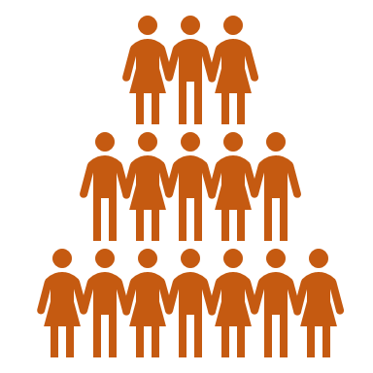  Artefacts and evidence  Change  Culture and pastimes  Society |  |  |  | People Who Help Us      Society  Comparison  Physical processes/features  Culture |  |  | New Life  Culture    Society  Comparison  Physical processes/features |  | Our Global Family  Comparison  Location  Society  Culture
Year 1 | Geography Detectives: Our City  Location    Human processes/features  Physical processes/features  Field work  Physical processes/features  Location |  |  |  |  | Through the Keyhole: School Days  Culture and pastimes  Artefacts and evidence  Change  Society |  |  |  |  | Geography Detectives: Our Country  Comparison  Location  Physical processes/features  Human processes/features  Culture |  |  |  |  |  | Through the Keyhole: London over Time  Artefacts and evidence    Power
Year 2 | Through the Keyhole: Kings and Queens  Society  Artefacts and evidence  Change |  |  |  |  | Through the Keyhole: Women in History  Society  Change  Power  Artefacts and evidence |  |  |  |  | Geography Detectives: Our Wonderful World  Physical processes/features  Human processes/features  Culture  Comparison  Location |  |  |  |  | Many Worlds One Planet: Amazing Africa  Human processes/features    Climate  Physical processes/features  Comparison  Location  Culture
Year 3 | Leaving a Legacy: Stone Age to Iron Age    Settlements  Change  Artefacts and evidence    Society  Locality |  |  |  |  | Many Worlds One Planet: Europe  Comparison  Culture  Location  Human processes/features  Climate |  |  |  |  | Leaving a Legacy: Ancient Greece  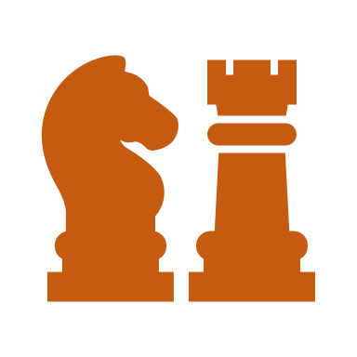  Culture and pastimes  Society  Artefacts and evidence  Conflict |  |  |  |  | Geography Detectives: Rivers, Rock and Rubble  Climate  Field work  Comparison  Physical processes/features
Year 4 | Leaving a Legacy: Ancient Egypt  Society  Power  Artefacts and evidence |  |  |  |  | Leaving a Legacy: Ancient Rome  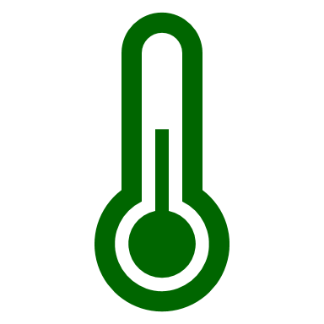  Climate change  Power  Conflict  Artefacts and evidence  Society  Culture and pastimes |  |  |  |  | Many Worlds One Planet: The Amazon  Location  Physical processes/features  Climate  Comparison |  |  |  |  | Many Worlds One Planet: USA  Comparison  Location  Human processes/features  Physical processes/features  Culture  Climate
Year 5 | Leaving a Legacy: Anglo-Saxon Britain  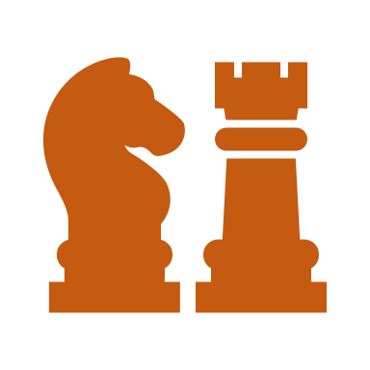  Locality  Settlements  Change  Conflict  Artefacts and evidence |  |  |  |  | Leaving a Legacy: Industrial Revolution  Artefacts and evidence  Change  Society |  |  |  |  | Many Worlds One Planet: Antarctica  Climate change  Comparison  Physical processes/features  Location |  |  |  |  | Geography Detectives: Volatile Earth  Physical processes/features  Climate change  Field work  Climate
Year 6 | Leaving a Legacy: Vikings  Power  Conflict  Settlements  Artefacts and evidence  Change |  |  |  |  | Leaving a Legacy: World War II  Change  Conflict  Power  Artefacts and evidence |  |  |  |  | Many Worlds One Planet: Asia  Comparison  Climate  Physical processes/features  Culture  Human processes/features  Location |  |  |  |  | Geography Detectives: A Planet Under Threat  Physical processes/features  Climate change  Field work  Climate

