 | Core Knowledge: Topic Four | Threads | NC objectives | Skills | Vocab
Y1 | Through the Keyhole: London over Time  The Gunpowder Pot-  Know that The Gunpowder Plot took place in London on the 5th November 1605  Know who Robert Catesby and Guy Fawkes were  Know that The Gunpowder Plot was a plot to kill King James I and his government by blowing up the Houses of Parliament.  Know why The Gunpowder Plot happened-  Know that the plot failed.  Know that Guy Fawkes was executed for his crime  Know what happens on the 5th November and what we are remembering  The Great Fire of London-  Know that the GFoL happened in 1666  Know where and how the fire started  Know the main events of the fire in a simple timeline  Know who Samuel Pepys was and what he did during the GFoL  Know why the fire spread so quickly  Know how people tried to stop the fire  Know how the fire ended  Know about some of the changes that happened in London after the fire ended  The London Olympics:  Know that the LO took place in 2012  Know some of the places where the Olympic Games took place  Know what the Olympic games are-  Know that ancient Olympics took place in Greece over 2000 years ago.  Know that the modern Olympics started in Greece over 100 years ago  Know why the Olympic games are important  The Coronation of King Charles III:  Know why King Charles became king  Know that Queen Elizabeth was his mother and died in September 2022  Know where an when the coronation took place  Know what the coronation ceremony is |   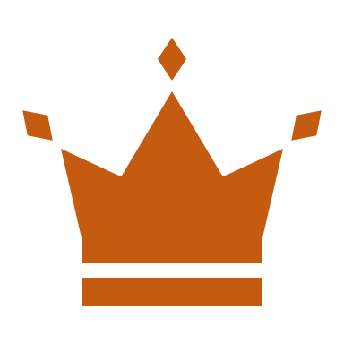  Artefacts and evidence  Power | Events beyond living memory that are significant nationally or globally | Sequence 3 or 4 artefacts from distinctly different periods of time  Recognise the difference between past and present in their own and others’ lives  To know and recount episodes from stories about the past  Find answers to simple questions about the past from sources of information e.g. artefacts | London, Gunpowder plot, Robert Catesby, Guy Fawkes, King James I, government, Houses of Parliament, executed, crime, Great Fire of London, Samuel Pepys, Olympics, Greece, Ancient, Coronation, King Charlies III, Queen Elizabeth, ceremony
 | Core Knowledge: Topic Three | Threads | NC objectives | Skills | Vocab
Y2 | Many Worlds One Planet: Africa  To know where Africa is on a map  To know that Africa is a continent  To know the seasonal and daily patterns  To know the location in relation to the Equator and the North and South Poles  To know the environmental regions, key physical and human characteristics, countries, and major cities  To know the countries and major cities within the continent of Africa and key topographical features (including hills, mountains, coasts and rivers)  To know the geographical similarities and differences through the study of human and physical geography of the United Kingdom, a region in an African Country; including population, climate and the water cycle, food and water  To know the 4 points of a compass |   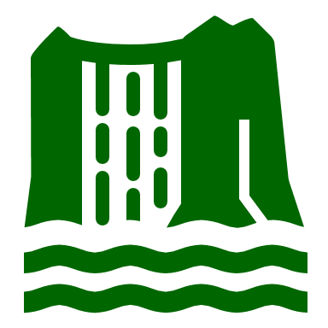  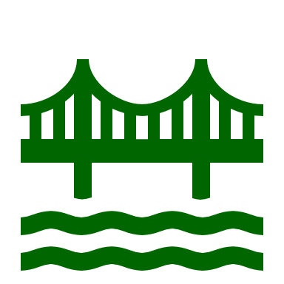  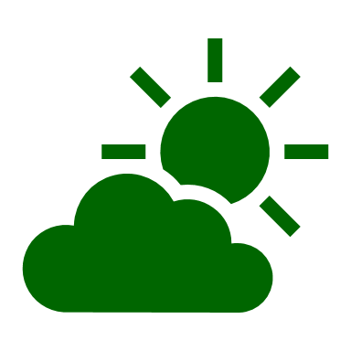  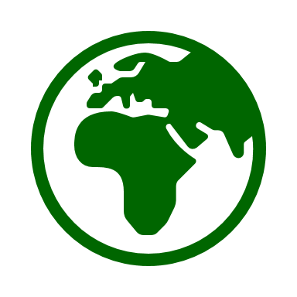    Culture  Physical processes/features  Human processes/features  Climate  Comparison  Location | understand geographical similarities and differences through studying the human and physical geography of a small area of the United Kingdom, and of a small area in a contrasting non-European country  use world maps, atlases and globes to identify continents and oceans studied at this key stage  use simple compass directions (North, South, East and West) and locational and directional language [for example, near and far; left and right], to describe the location of features and routes on a map  identify seasonal and daily weather patterns and the location of hot and cold areas of the world in relation to the Equator and the North and South Poles  use aerial photographs and plan perspectives to recognise landmarks and basic human and physical features; devise a simple map; and use and construct basic symbols in a key | Use world maps, atlases and globes to identify Africa and surrounding oceans  To be able to compare Africa with a small area of the UK  Name and locate countries and major cities within the continent of Africa and key topographical features (including hills, mountains, coasts and rivers)  To be able to identify human and physical geography of Africa  To be able to identify the seasons and weather in Africa  To be able to identify the Equator, North and South Poles on a map and atlas  To be able to use the 4 points of a compass | Africa, continent, regions, human and physical features, population, climate, compass, Equator, North and South Poles
 | Core Knowledge: Topic Three | Threads | NC objectives | Skills | Vocab
Y3 | Geography Detectives: Rivers, Rock and Rubble  To know the names of major rivers in the UK  To know the location of major rivers in the UK  To know the name of the seas that the rivers flow into  To know some of the advantages and disadvantages of rivers  To know what a meander is  To know how rivers have changed over time and what causes this to happen  To know the names of the three different types of rock  To know where the three types of rock are found and how they are formed  To know some of the properties of the three types of rock  To know how to observe and record physical features in the local area |   Field work  Comparison  Physical processes  Climate | Name and locate counties and cities of the United Kingdom, geographical regions and their identifying human and physical characteristics, key topographical features (including hills, mountains, coasts and rivers), and land-use patterns; and understand how some of these aspects have changed over time  Describe and understand key aspects of: physical geography, including: climate zones, biomes and vegetation belts, rivers, mountains, volcanoes and earthquakes, and the water cycle  Use fieldwork to observe, measure, record and present the human and physical features in the local area using a range of methods, including sketch maps, plans and graphs, and digital technologies. | To identify and locate rivers on a map  To be able to follow a river on a map to find where it starts and ends.  To identify meanders on a map  To be able to identify and explain how some rivers have changed  To be able to identify the properties of different types of rocks and to sort accordingly  To be able to carry out fieldwork in the local area | Rivers, location, meander, source, mouth, igneous, sedimentary, metamorphic, formation, volcano, Erodes, riverbank,
 | Core Knowledge: Topic Three | Threads | NC objectives | Skills | Vocab
Y4 | Many Worlds One Planet: USA  To know that North America is the 3rd largest continent and it is made up of 23 countries  To know that North America is in the northern hemisphere  To know the difference between North and South America  To know that USA is in North America  To know that the USA has 50 states  To know some key landmarks in the USA and which state they are in (Statue of Liberty, Washington Monument, Golden Gate Bridge, Mount Rushmore, The White House)  To know where the Grand Canyon is and to know how it was formed. To know the climate and wildlife in the Grand Canyon  To know where Niagara Falls are. To know how they were formed. To know the economic use of the falls (hydropower plant) | Physical processes/features  Climate  Human processes/features  Culture  Location | locate the world’s countries, using maps to focus on Europe (including the location of Russia) and North and South America, concentrating on their environmental regions, key physical and human characteristics, countries, and major cities  identify the position and significance of latitude, longitude, Equator, Northern Hemisphere, Southern Hemisphere  understand geographical similarities and differences through the study of human and physical geography of a region of the United Kingdom, a region in a European country, and a region within North or South America  physical geography, including: climate zones, biomes and vegetation belts, rivers, mountains, volcanoes and earthquakes, and the water cycle  human geography, including: types of settlement and land use, economic activity including trade links, and the distribution of natural resources including energy, food, minerals and water  use maps, atlases, globes and digital/computer mapping to locate countries and describe features studied  use the eight points of a compass, four and six-figure grid references, symbols and key | To locate the world’s countries, using maps to focus on North and South America, concentrating on their environmental regions, key physical and human characteristics, countries, and major cities  To name and locate countries and major cities within the continents of North and South America and key topographical features  To use maps, atlases, globes and digital/computer mapping to locate North and South America with a focus on the USA  To use the eight points of a compass, four and six-figure grid references, symbols and key  To use recognised symbols to mark out local areas of interest on own maps. - Choose effective recording and presentation methods e.g. tables to collect data. | Continent, hemisphere, equator, states, canyon, waterfalls, plunges, hydropower, source, glaciers, valley, erosion,
 | Core Knowledge: Topic Three | Threads | NC objectives | Skills | Vocab
Y5 | Geography Detectives: Volatile Earth  To know the layers of the earth  To know what tectonic plates are  To know what a volcano is and how they are formed  To know the layers of a volcano  To know what causes a volcano to erupt  To know the 3 types of rock  To know what lava and magma are  To know where the major volcanoes in the world are  To know the key aspects of earthquakes  To know how scientists measure earthquakes (Seismography, Richter scale, Moment Magnitude)  To know what an ‘epicenter’ is  To know some of the countries where earthquakes have happened | 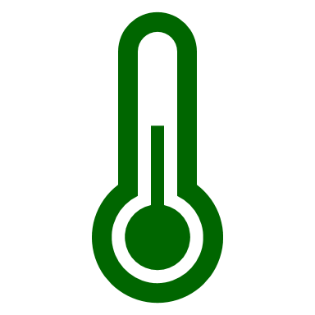  Climate  Field work  Climate change  Physical processes/features | describe and understand key aspects of: physical geography, including: climate zones, biomes and vegetation belts, rivers, mountains, volcanoes and earthquakes, and the water cycle  use maps, atlases, globes and digital/computer mapping to locate countries and describe features studied  use the eight points of a compass, four and six-figure grid references, symbols and key (including the use of Ordnance Survey maps) to build their knowledge of the United Kingdom and the wider world  use fieldwork to observe, measure, record and present the human and physical features in the local area using a range of methods, including sketch maps, plans and graphs, and digital technologies. | To be able to name layers of the earth  To use maps, atlases, globes and digital/computer mapping to locate volcanoes  To be able to describe how volcanoes are formed and what causes them to erupt  To be able to use the eight points of a compass and six- figure refences, symbols and key when locating counties which have a volcano or where earthquakes have occurred  To be able to describe how magma is formed  To be able to use Seismographs, Richter scale, Moment Magnitude to observe and record data | Tectonic plates, crust, mantle, core, magnitude, magma, solidified, lava, seismograph, igneous, sedimentary, metamorphic, formation, erupt, shockwaves, Richter scale, tremor, epicenter
 | Core Knowledge: Topic Three | Threads | NC objectives | Skills | Vocab
Y6 | Geography Detectives: A Planet Under Threat  Know that equator is an imaginary line around the middle of the Earth.  Know that climate change (global warming) is the process of the planet heating up  Know that climate change is already having huge impacts across the planet for people and wildlife.  Know that The Earth’s climate is getting warmer because of human activity.  Know that humans burn fossils fuels like coal, oil and natural gas for energy and greenhouse gases are released into the atmosphere.  Know that humans also cut down trees across our planet to make space for things like farming and expanding cities.  Know that Greenhouse gases keep our planet warm.  Know that climate change is causing more extreme weather events.  Know what we can do to reduce the amount of greenhouse gas emissions | Field work  Climate change  Climate  Physical processes/features | describe and understand key aspects of: physical geography, including: climate zones, biomes and vegetation belts, rivers, mountains, volcanoes and earthquakes, and the water cycle : human geography, including: types of settlement and land use, economic activity including trade links, and the distribution of natural resources including energy, food, minerals and water  use maps, atlases, globes and digital/computer mapping to locate countries and describe features studied  use the eight points of a compass, four and six-figure grid references, symbols and key (including the use of Ordnance Survey maps) to build their knowledge of the United Kingdom and the wider world  use fieldwork to observe, measure, record and present the human and physical features in the local area using a range of methods, including sketch maps, plans and graphs, and digital technologies. | To be able to identify climate zones  To be able to explain the impact of climate change on the earth  To use digital/computer mapping to observe the affects of climate change  To be able to explain the impact of greenhouse gases  To use fieldwork to observe and record the changes of the physical features due to climate change  To be able to explain why deforestation happens and the impact of this  To be able to explain what we can do to reduce the amount of greenhouse gas emissions | Climate equator climate change global warming fossil fuels greenhouse gases emissions carbon dioxide atmosphere heatwave drought

