 | Core Knowledge: Topic Three | Threads | NC objectives | Skills | Vocab
Y1 | Geography Detectives: Our Country  Know the names of the 4 UK countries and the capital cities  Name the surrounding seas  To know the human and physical features of the four countries and their capital cities  To know the seasonal and daily weather patterns in the UK | 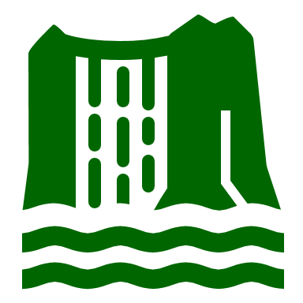  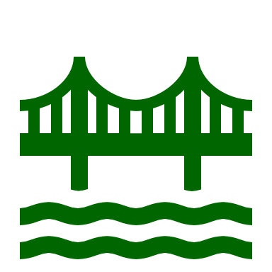    Physical processes/features  Human processes/features  Culture    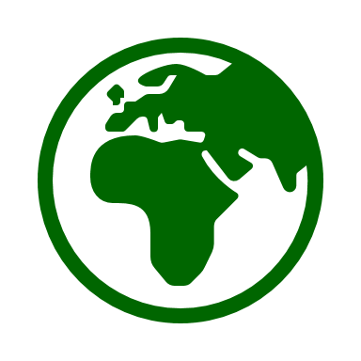  Location  Comparison | Name, locate and identify characteristics of the four countries and capital cities of the United Kingdom and its surrounding seas  Identify seasonal and daily weather patterns in the United Kingdom  Use basic geographical vocabulary to refer to: key physical features, including: beach, cliff, coast, forest, hill, mountain, sea, ocean, river, soil, valley, vegetation, season and weather key human features, including: city, town, village, factory, farm, house, office, port, harbour and shop  use world maps, atlases and globes to identify the United Kingdom and its countries  use aerial photographs and plan perspectives to recognise landmarks and basic human and physical features; devise a simple map; and use and construct basic symbols in a key | To identify seasonal and daily weather patterns in the United Kingdom  To name, locate and identify characteristics of the four countries and capital cities of the United Kingdom and its surrounding seas.  To identify seasonal and daily weather patterns in the United Kingdom | North/ south  Weather, seasonal,  Equator, key physical features, including: beach, cliff, coast, forest, hill, mountain, sea, ocean, river, soil, valley, vegetation, season and weather key human features, including: city, town, village, factory, farm, house, office, port, harbour and shop, map, atlas, UK,
 | Core Knowledge: Topic Three | Threads | NC objectives | Skills | Vocab
Y2 | Geography Detectives: Our Wonderful World  To know the names of the 4 UK countries and the capital cities (re-cap from Year 1)  To know the seven continents and the five oceans  To know where the Equator is  To know where the North and South Poles are  To know the seasonal and daily weather patterns of hot and cold areas of the world in relation to the Equator and the North and South Poles  To know what a compass is and to know simple compass directions  To know what an aerial photograph is  To know what a map is and what simple map symbols are | Comparison  Culture  Physical processes/features  Human processes/features  Location | Name and locate the world’s seven continents and five oceans  Identify seasonal and daily weather patterns and the location of hot and cold areas of the world in relation to the Equator and the North and South Poles  Use world maps, atlases and globes to identify the United Kingdom and its countries, as well as the countries, continents and oceans studied at this key stage  Use simple compass directions (North, South, East and West) and locational and directional language [for example, near and far; left and right], to describe the location of features and routes on a map  Use aerial photographs and plan perspectives to recognise landmarks and basic human and physical features; devise a simple map; and use and construct basic symbols in a key | To name and locate the four countries and capital cities of the UK (recap from Y1)  To name and locate the seas surround the UK countries  (recap from Y1)  To use a compass alongside positional language to describe the location of feature and routes on a map.  To locate the equator on a world map  To identify seasonal and daily weather patterns in the North and South Poles  To use world maps, atlases and globes to identify Europe and surrounding oceans  To use aerial photographs and plan perspectives to recognise landmarks and basic human and physical features; devise a simple map; and use and construct basic symbols in a key | Country, continent, city, ocean, equator, north/ south poles, seasonal, weather patterns, compass, maps, atlases, landmarks, human and physical features, North, South, East, West
 | Core Knowledge: Topic Three | Threads | NC objectives | Skills | Vocab
Y3 | Leaving a Legacy: Ancient Greece  Know where and when the Ancient Greeks lived  Know the dates of key events in the Ancient Greek timeline  Know that Ancient Greece was made up of city states. The most important city states were: Athens, Sparta and Corinth.  Know about the city state of Athens: The Athenians were known for their cultural developments and learning.  To know Athens is where democracy began in around 508 BC.  Know about the city state of Sparta  Know about the Trojan Wars  Know about the first Olympic Games: |   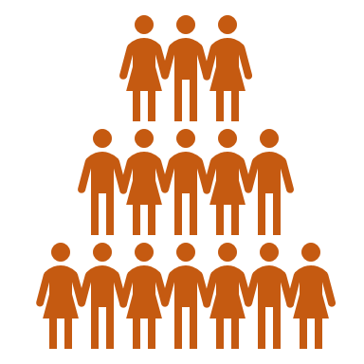    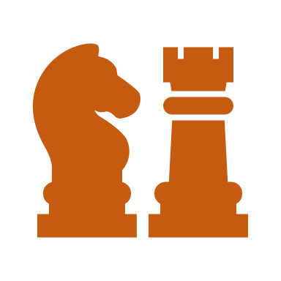    Culture and pastimes  Society  Artefacts and evidence  Conflict | Ancient Greece – a study of Greek life and achievements and their influence on the western world | To locate Greece on a world map  To create a timeline from the Ancient Greek time including key time periods/ events  To use different sources including artefacts, art and written sources to find out historical information  To identify the key features and the similarities and differences between the key periods of time | City states, democracy, debating, vote, warriors, legacy, citizens, surrender, cultural developments, Athenians, Spartans, Trojans, Trojan war, boxing, wrestling, chariot racing
 | Core Knowledge: Topic Three | Threads | NC objectives | Skills | Vocab
Y4 | Many Worlds One Planet: The Amazon  Know the Amazon river begins in the Andes Mountains and flows to the Atlantic Ocean.  Know that The Amazon river and its tributaries flow through many counties  Know the different layers of the rainforest  Know that The Amazon river is thought to be at least 6,400km long and the second longest in the world.  Know that the Amazon River flows through The Amazon Rainforest.  Know The Amazon rainforest approximately 6.7 million square kilometres which makes it the largest remaining tropical rainforest in the world.  Know The Amazon Rainforest is home to  40 00- plant species and 2.5 million insect species.  The Amazon rainforest is home  to 10% of the world's known biodiversity  Know that the Amazon Rainforest produces 20% of the world’s oxygen.  To know the climate of the Amazon rainforest  To know about deforestation |   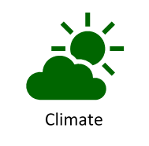  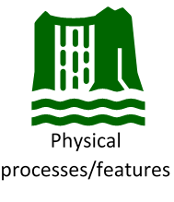  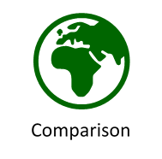  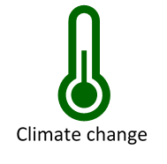 | locate the world’s countries, using maps to focus on Europe (including the location of Russia) and North and South America, concentrating on their environmental regions, key physical and human characteristics, countries, and major cities  identify the position and significance of latitude, longitude, Equator, Northern Hemisphere, Southern Hemisphere, the Tropics of Cancer and Capricorn, Arctic and Antarctic Circle, the Prime/Greenwich Meridian and time zones (including day and night)  describe and understand key aspects of:  ▪ physical geography, including: climate zones, biomes and vegetation belts, rivers,  mountains, volcanoes and earthquakes, and the water cycle | To use maps, atlases, globes and digital computer mapping to name and locate the equator, northern hemisphere, southern hemisphere, the tropics and different rainforests around the world  To describe key aspects of physical geography within the rainforest (layers and biodiversity)  To use a range of sources to identify the key human features of a location  To locate world’s countries (South America), environmental regions, key physical and human characteristics, countries, major cities, vegetation belts, climate zones and biomes on a map (compare sustainability levels between South America and England).  To understand geographical similarities and differences  To know about deforestation and the effects on the environment | Andes Mountains, Atlantic Ocean, tributaries, biome, tropical rainforest, species, biodiversity, humid, tropical, climate, emergent layer, canopy layer, understorey, forest floor, deforestation
 | Core Knowledge: Topic Three | Threads | NC objectives | Skills | Vocab
Y5 | Many Worlds One Planet: Antarctica  To know Antarctica is the southernmost continent in the world and contains the South Pole.  To know it has no countries and its population is zero.  To know the climate in Antarctica  To know the size of Antarctica changes with the seasons  To know very few living things live in Antarctica all year.  To know what climate change is  To know the affect of climate change in Antarctica  To know some of the physical features of Antarctica (Transantarctic mountain range, Arctandes, Sentinel range, Meltwater rivers) | 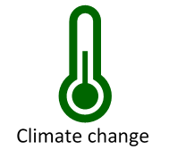  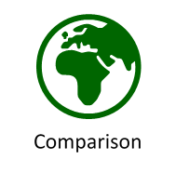 | identify the position and significance of latitude, longitude, Equator, Northern Hemisphere, Southern Hemisphere, the Tropics of Cancer and Capricorn, Arctic and Antarctic Circle, the Prime/Greenwich Meridian and time zones (including day and night)  physical geography, including: climate zones, biomes and vegetation belts, rivers, mountains, volcanoes and earthquakes, and the water cycle  use fieldwork to observe, measure, record and present the human and physical features in the local area using a range of methods, including sketch maps, plans and graphs, and digital technologies. | To be able to locate Antarctica on a world map and identify its position in relation to the equator, Northern Hemisphere, Southern Hemisphere, the Tropics of Cancer and Capricorn, Arctic and Antarctic Circle  To be able to explain the physical geography of Antarctica  To be able to explain what climate change is and how it is affecting Antarctica  To be able to use fieldwork to observe the physical features of Antarctica | population distribution,  meltwater, latitude, longitude,  Greenwich Meridian
 | Core Knowledge: Topic Three | Threads | NC objectives | Skills | Vocab
Y6 | Many Worlds One Planet: Asia  Know Asia is one of the world’s seven continents and know its location on the world map.  Know it is the biggest continent by area and also has the largest population  Know that Asia is made up of 48 countries.  Know the names of the main countries and their location on a world map  Know a biome is an area with a distinctive climate and vegetation.  Know the different Biomes found in Asia: Gobi Desert, Temperate Grasslands, Coniferous Forests, Tropical Rainforests, Tundra, Himalayas, Mount Everest | Comparison  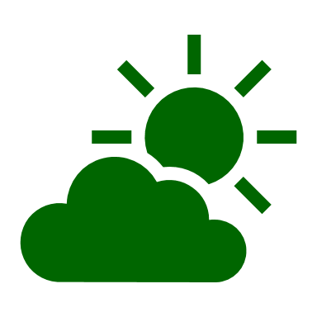  Climate  Human processes/features  Culture  Physical processes/features  Location | identify the position and significance of latitude, longitude, Equator, Northern Hemisphere, Southern Hemisphere, the Tropics of Cancer and Capricorn, Arctic and Antarctic Circle, the Prime/Greenwich Meridian and time zones (including day and night)  describe and understand key aspects of:  physical geography, including: climate zones, biomes and vegetation belts, rivers,  mountains, volcanoes and earthquakes, and the water cycle  human geography, including: types of settlement and land use, economic activity  including trade links, and the distribution of natural resources including energy,  food, minerals and water  use maps, atlases, globes and digital/computer mapping to locate countries and  describe features studied | To be able to label Asia on a world map  To be able to label some of Asia’s countries on a world map  To be able to locate the Equator, Northern Hemisphere, Southern Hemisphere, the Tropics of Cancer and Capricorn  To be able to explain the physical geography of Asia  To be able to explain the human geography of Asia  To describe and understand biomes | Continent, biome, climate, vegetation, temperate grasslands, shrubland, plains, steppes, coniferous, tundra, permafrost

