 | Core Knowledge: Topic Two | Threads | NC objectives |  | Skills | Vocabulary
Y1 | Through the Keyhole: School Days:  Know the name of our school and its original name, when it was built and how old it is.  Know some of the ways that our school has changed over time: its name, the headteacher, the classrooms, the field, the playground.  Know about schools 100 years ago and schools today: what a classroom looked like, what equipment teachers used, what equipment children used, what lessons were taught. |         Artefacts and evidence  Culture and pastimes  Change | Changes within living memory. Where appropriate, these should be used to reveal aspects of change in national life |  | To understand the concept of history (past and present)  To recognise the difference between past and present in their own and others lives  To know and recount episodes from stories about the past  To find answers to simple questions about the past from sources of information | St William’s, Catholic, St John The Baptist Trust, Headteacher, Victorian, classroom, chalk, chalkboard, slate,
 | Core Knowledge: Topic Two | Threads | NC objectives |  | Skills | Vocabulary
Y2 | Amelia Earhart:  Know that Amelia Earhart was born in America, she had a passion for flying from an early age  First woman (and only the second person) to fly solo across The Atlantic Ocean  Broke many flying records including being the first person to fly solo from Hawaii to California  Died in 1937 when her plane disappeared while she was attempting to fly around the world.  Rosa Parks:  Know that she was born in 1913 in Alabama in the USA  She lived in a time of segregation when black and white people were not treated equally  Arrested because she refused to give up her seat on a bus for a white man which led to a bus boycott by black people,  1956 the segregation law changed but she continued to fight for equal rights, she died in 2005.  Greta Thunberg: Know that she was born in Stockholm, Sweden in 2003, when she was 11 she became an environmental activist because she was very sad about the problem of climate change, in 2018 she went on strike from school and sat outside the Swedish Parliament with a sign that said ‘School Strike for Climate, since then she has made TV documentaries and written books about the problem of climate change. |   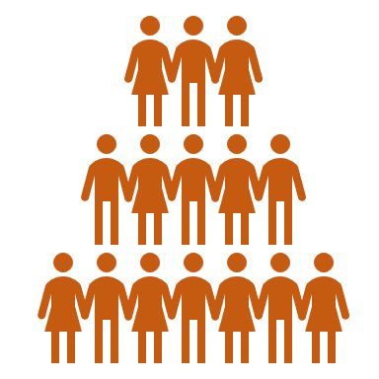      Change  Society  Power  Artefacts and evidence | The lives of significant individuals in the past who have contributed to national and  international achievements. Some should be used to compare aspects of life in  different periods |  | To understand how a historical timeline works.  To create a simple timeline of key events for each significant individual  To use a source – observe or handle sources to answer questions about the past on the basis of simple observations.  To compare pictures or photographs of people or events in the past  To discuss reliability of photos/ accounts/stories  To recognise why people did things, why events happened and what happened as a result  Identify differences between ways of life at different times | Aeroplane, flight, solo, segregation, boycott, strike, equal rights, climate change, environmental activist, law, Atlantic ocean, activities, United States of America, Sweden,
 | Core Knowledge: Topic Two | Threads | NC objectives |  | Skills | Vocabulary
Y3 | Many Worlds One Planet: Europe  Know the names and location of the 4 UK countries and their capital cities  Know the names and location of the main counties and cities of England  Know the human and physical characteristics of the UK  Know the names and locations of the continents and the major countries of the world.  Know the seven wonders of the world- Names and locations (human and physical characteristics)  To know the name and location of Greece (including Athens) |   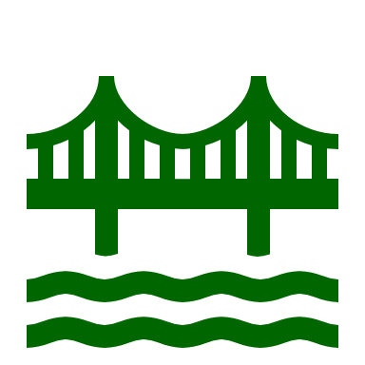      Comparison  Human processes/features  Culture   | Name and locate counties and cities of the United Kingdom, geographical regions and their identifying human and physical characteristics, key topographical features (including hills, mountains, coasts and rivers), and land-use patterns; and understand how some of these aspects have changed over time  Locate the world’s countries, using maps to focus on Europe (including the location of Russia) and North and South America, concentrating on their environmental regions, key physical and human characteristics, countries, and major cities  use maps, atlases, globes and digital/computer mapping to locate countries and describe features studied |  | To use atlases, locate continents and major countries of the world, the UK (and its capital cities and counties)  To identify human and physical characteristics of the UK.  To identify human and physical features of the world.  To name and locate the world’s seven continents and five oceans.  To understand geographical similarities and differences through studying the human and physical geography of a small area of Europe.  To locate Greece on a map | Location, country, continent, counties, physical, human, features/ characteristics, atlas, globe, map, Europe, climate, locate, region
 | Core Knowledge: Topic Two | Threads | NC objectives |  | Skills | Vocabulary
Y4 | Leaving a Legacy: Ancient Rome  Know who the Romans were and where they came from  Know when the Romans invaded Britain  Know why the Romans invaded Britain  Know that the Romans built Hadrian’s wall to defend themselves from invaders from the north  Know why and how the Romans built new roads and towns in Britain  Know who Boudicca was and know about the rebellion she led against the Romans  Know what life was like in a Roman Villa in Britain  Know about the ways in which the Roman Empire has had a lasting impact on Britain |     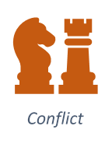    Artefacts and evidence     | The Roman Empire and its impact on Britain |  | To locate Italy and Rome on a map  To place events from period studied on time line  To use terms related to the period and begin to date events  To understand more complex terms eg BC/AD  To develop a timeline of key events in the Ancient Rome time period  To identify key features and events of time studied  To look for links and effects in time studied  To offer a reasonable explanation for some events  To begin to evaluate the usefulness of different sources  To use text books and historical knowledge | Romans, invasion, Hadrian’s wall,  Invaders, Boudicca, rebellion, villa, town, impact, legacy, Empire,
 | Core Knowledge: Topic Two | Threads | NC objectives |  | Skills | Vocabulary
Y5 | Leaving a Legacy: Industrial Revolution  Know that The Industrial Revolution was a period of huge change in Britain between 1750 and 1900.  Know that before the Industrial Revolution, Britain was a rural country. Most people lived off the land with livestock.  Know that Queen Victoria was the reigning monarch for a large part of the Industrial Revolution (1837-1901)  Know how the Industrial Revolution began-people began to realise that coal and steam could be used to power factories, large machines, flour and cotton mills.  Know that huge factories were built and where they were built.  Know about how certain towns rapidly expanded  Know that many people moved to the towns and why  Know what life was like for poor people in The Industrial Revolution  Know about some of the key inventions of The Industrial Revolution- such as the steam engine, the locomotive, the car (internal combustion engine), the electric telegraph, the typewriter, the Spinning Jenny |    | A study of an aspect or theme in British history that extends pupils’ chronological  knowledge beyond 1066  A significant turning point in British history, for example, The Industrial Revolution |  | To draw a timeline to show when the Industrial Revolution was in history and how this links to other time periods studied.  To use different sources including artefacts, art and written sources to find out historical information  To compare the reliability of different sources of historical information.  To know and sequence key events of time studied  To use relevant terms and period labels  To make comparisons between different times in the past  To study different aspects of different people - differences between men and women  To examine causes and results of great events and the impact on people | Industrial revolution, livestock, rural, town, city, steam, factory, Queen Victoria, Spinning Jenny, coal, steam, train, locomotive, engine, internal combustion engine, monarch, expanded, reign
 | Core Knowledge: Topic Two | Threads | NC objectives | Skills |  |  | Vocabulary
Y6 | Leaving a Legacy: World War Two  Know why Britain went to war in 1939  Know why children were evacuated in World War Two  Know what life was like for evacuees  Know what life was like for people living in Britain in World War Two: rationing, blackouts, air raids,  Know about the Dunkirk evacuation- when it happened, why it happened, where it happened, what happened  Know about the Battle of Britain- when it happened, why it happened, where it happened, what happened  Know about the impact of the war on the city of Peterborough  Know about the impact of the war on Jewish people overseas-  Know about Kristallnacht- when it happened, why it happened, where it happened, what happened  Know about The Holocaust- when it happened, why it happened, where it happened, what happened  Know the events that brought World War Two to an end: The Battle of Stalingrad and the D-Day Invasion of Normandy | 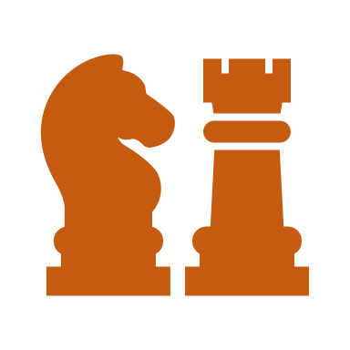  Artefacts and evidence  Conflict    Power  Change | a study of an aspect or theme in British history that extends pupils’ chronological knowledge beyond 1066 | To place current study on time line in relation to other studies  To use relevant dates and terms  To sequence up to 10 events on a time line  To know key dates, characters and events of time studied  To use different sources including artefacts, art and written sources to find out historical information  To link sources and work out how conclusions were arrived at  To consider ways of checking the accuracy of interpretations – fact or fiction and opinion  To be aware that different evidence will lead to different conclusions  Confidently use the library and internet for research  To recognise primary and secondary sources  To use a range of sources to find out about an aspect of time past  To suggest omissions and the means of finding out  To compare the reliability of different sources of historical information. |  |  | War, evacuees, rationing, blackouts, air- raids, Dunkirk, evacuation, impact, Kristallnacht, The Holocaust, Battle of Stalingrad, D Day, invasion, Normandy

