 | Core Knowledge: Topic One | Threads | NC Objectives |  | Skills | Vocabulary
1 | Geography Detectives: Our City  To know we live in Peterborough and that Peterborough is in England.  Know where England is situated on a map of The UK.  Know where Peterborough is situated in England.  Learn and understand what human and physical features are.  Know some of the human and physical features of Peterborough: River Nene, Fens, Grimshaw wood.  Cathedral, train station, bus station, Queensgate, Town Bridge, Longthorpe Tower, Thorpe Hall, factories, farms, offices  Know simple map symbols  Know the 8 points of a compass |       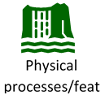 | Understand geographical similarities and differences through studying the human and physical geography of a small area of the United Kingdom  Use basic geographical vocabulary to refer to:  key physical features, including: forest, river,  key human features, including: city, town, village, factory, farm, house, office, shop  Use simple compass directions (North, South, East and West) and locational and directional language [for example, near and far; left and right], to describe the location of features and routes on a map  use aerial photographs and plan perspectives to recognise landmarks and basic human and physical features; devise a simple map; and use and construct basic symbols in a key  Use simple fieldwork and observational skills to study the geography of their school and its grounds and the key human and physical features of its surrounding environment. |  | To use world maps, atlases and globes to identify the United Kingdom  To locate Peterborough and England on a map of the UK  To use simple compass directions (North, South, East and West)  To use simple fieldwork and observational skills to study the geography of their school and its grounds and the key human and physical features of its surrounding environment  To understand geographical similarities and differences through studying the human and physical geography of Peterborough  To identify and use a range of map symbols  To be able to draw and label a simple map | Location, city, town, country, compass, compass direction (North, South, East, West), near and far; left and right human features, physical features, map, ariel photograph, symbols, landmark, environment,
 | Core Knowledge: Topic One | Threads | NC Objectives | Skills |  | Vocabulary
2 | Through the Keyhole: Kings and Queens  Know that our current monarch is King Charles III who became king after Queen Elizabeth II (his mother) died in 2022.  Know that Queen Elizabeth II was the longest reigning monarch. She reigned for 70 years.  Know who Queen Victoria was and that she was queen for almost 64 years (1837-1901). This time was called the Victorian period. Cars and trains were invented during this time.  Know who King Henry VIII (1509-1547) was and that he was desperate for a son, so when his wife Katherine of Aragon gave birth to a baby girl,  he divorced her. In doing so, he split England from the Catholic Church and created the Church  of England.  Henry had a total of six wives; he divorced two and beheaded two.  Elizabeth I (1558-1603) was the daughter of Henry VIII.  She never married and didn’t have any children. |   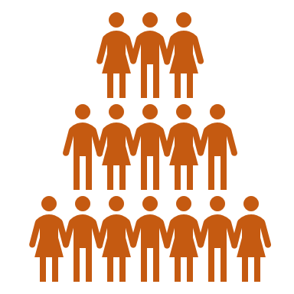  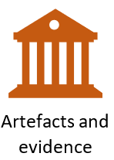  Change  Society | The lives of significant individuals in the past who have contributed to national and international achievements. Some should be used to compare aspects of life in different periods [for example, Elizabeth I and Queen Victoria,  Events beyond living memory that are significant nationally or globally | To understand how a historical timeline works.  To be able to create a simple timeline of key events for each monarch  To use a source – observe or handle sources to answer questions about the past on the basis of simple observations.  To recognise why people did things, why events happened and what happened as a result |  | King, Queen, monarch, reign, coronation, jubilee, Victorian period, divorced, beheaded, died, Catholic Church, Church of England,
3 | Leaving a Legacy: Stone Age to Iron Age  Know when the Stone Age, Bronze Age and Iron Age began and ended  Know that the earliest settlers were hunter gatherers and lived in caves  Know that Stone Age man produced cave art  Know how life changed in The Stone Age when man began to farm  Know what life was like in Skara Brae (Neolithic village)  Know how, where, when and why Stonehenge was built  Know that people in the Bronze Age lived in roundhouses  Know what life was like living in a roundhouse  Know that people in the Iron Age lived in farming communities on hilltops called hill forts  Know what life was like living in a Bronze Age hill fort |   Settlements  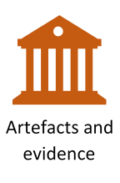  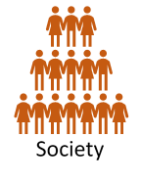     | Changes in Britain from the Stone Age to the Iron Age | To create a timeline from the stone Age to Iron Age including key time periods/ events  To use different sources including artefacts, art and written sources to find out historical information  To identify the key features and the similarities and differences between the key periods of time  To look at representations of the period – museum, cartoons etc  To begin to use the library and internet for research |  | Stone Age, Iron Age,  Bronze Age, cave art, hunter gathers, Skara Brae, roundhouse, prehistoric, settlement, tribe, archaeologist, palaeolithic, Mesolithic, Neolithic,
4 | Leaving a Legacy: Ancient Egypt  Know who the Ancient Egyptians were, where they lived and when they lived.  Know what life in Ancient Egypt was like: such as jobs, houses, food, clothes  Know about the importance of The River Nile to The Ancient Egyptians  Know about the process of mummification  Know about Egyptian written communication- hieroglyphics  Know who Tutankhamun was and when he lived  Know how his tomb was discovered  Know what his tomb revealed about his life | 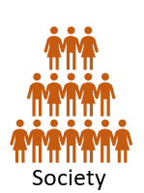      Power | The achievements of the earliest civilizations – an overview of where and when the first civilizations appeared and a depth study of Ancient Egypt | To develop a timeline of key events in the Ancient Egypt time period  To use different sources including artefacts, art and written sources to find out historical information  To place events from period studied on time line  To use terms related to the period and begin to date events  To understand more complex terms eg BC/AD  To use evidence to reconstruct life in time studied  To be able to identify key features and events of time studied  To be able to look for links and effects in time studied  To offer a reasonable explanation for some events |  | Ancient, pharaoh, hieroglyphics, pyramids, River Nile, Tutankhamun, tomb, mummification,  Civilisation,
 | Core Knowledge: Topic One | Threads | NC Objectives | Skills |  | Vocabulary
5 | Leaving a Legacy: Anglo-Saxon Britain  Know when (450AD) and why the Anglo-Saxons invaded Britain  Know where The Anglo-Saxons came from  Know where the Anglo Saxons settled in Britain and the names of the places they settled in  Know about life in an Anglo-Saxon village: houses, jobs, food, clothing  Know about Anglo Saxon art and culture  Know how the Anglo-Saxons were converted to Christianity in Britain | 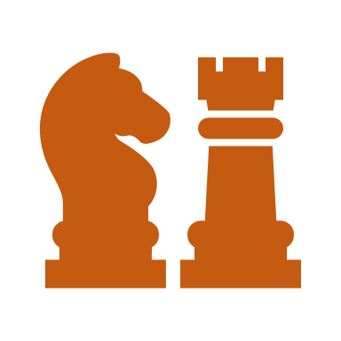  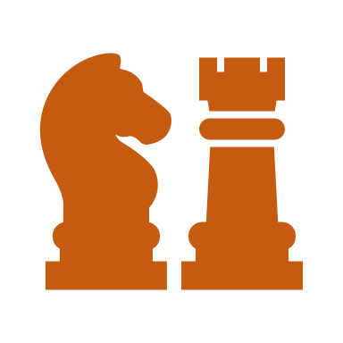  Locality  Change  Conflict  Settlements | Britain’s settlement by Anglo-Saxons and Scots | To draw a timeline to show when Anglo Saxon Britain was in history and how this links to other time periods studied.  To use different sources including artefacts, art and written sources to find out historical information  To compare the reliability of different sources of historical information.  To know and sequence key events of time studied  Use relevant terms and period labels  To be able to make comparisons between different times in the past  To be able to compare accounts of events from different sources – fact or fiction and offer some reasons for different versions of events  To be able to use the library and internet for research with increasing confidence |  | Invaded, invasion, settlement, settlers, Wergild, legacy, runes, Bayeux, tribes, Wessex, Mercia, Northumbria, Essex, Derbyshire, Leicestershire Kent, East Anglia Cambridgeshire,  Pagan
6 | Leaving a Legacy: Invasion  Know that the Viking age began around 1200 years ago and lasted for just over 200 years.  Know where the Vikings settled in Britain and the names of the places they settled in  Know about the Viking attack on Lindisfarne in 793  Know about the capture of York in 867  Know about the treaty between Guthram and King Alfred of Wessex (Danelaw).  Know that Danegeld was money paid to stop the Vikings raiding.  Give reasons why the Vikings chose to attack Britain – combination of overpopulation at home to relative weakness of victims abroad.  Know how the Vikings lived: family life, homes, jobs  Know about Viking ships- long boats and cargo vessels  Know about Know about the treaty between Guthram and King Alfred of Wessex (Danelaw). | Conflict  Change  Power  Settlements | The Viking and Anglo-Saxon struggle for the Kingdom of England to the time of Edward the Confessor | To draw a timeline to show when the Viking Age was in history and how this links to other time periods studied.  To be able to place current study on time line in relation to other studies  To be able to use relevant dates and terms  To know key dates, characters and events of time studied  To be able to develop a timeline of key events in the Viking time period  To be able to compare the reliability of different sources of historical information.  To be able to recognise primary and secondary sources  To use a range of sources to find out about an aspect of time past  To be able to bring knowledge gathered from several sources together in a fluent account |  | Lindisfane, Guthram, King Alfred, Wessex, Dane Law,  Population, long boat, cargo vessel, Jorvik, exile, pagan

