 | Core Knowledge: Topic One | Threads | NC Objectives | Skills | Vocabulary
1 | Geography Detectives: Our City  To know we live in Peterborough and that Peterborough is in England.  Know where England is situated on a map of The UK.  Know where Peterborough is situated in England.  Learn and understand what human and physical features are.  Know some of the human and physical features of Peterborough: River Nene, Fens, Grimshaw wood.  Cathedral, train station, bus station, Queensgate, Town Bridge, Longthorpe Tower, Thorpe Hall, factories, farms, offices  Know simple map symbols  Know the 8 points of a compass |       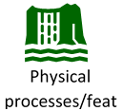 | Understand geographical similarities and differences through studying the human and physical geography of a small area of the United Kingdom  Use basic geographical vocabulary to refer to:  key physical features, including: forest, river,  key human features, including: city, town, village, factory, farm, house, office, shop  Use simple compass directions (North, South, East and West) and locational and directional language [for example, near and far; left and right], to describe the location of features and routes on a map  use aerial photographs and plan perspectives to recognise landmarks and basic human and physical features; devise a simple map; and use and construct basic symbols in a key  Use simple fieldwork and observational skills to study the geography of their school and its grounds and the key human and physical features of its surrounding environment. | To use world maps, atlases and globes to identify the United Kingdom  To locate Peterborough and England on a map of the UK  To use simple compass directions (North, South, East and West)  To use simple fieldwork and observational skills to study the geography of their school and its grounds and the key human and physical features of its surrounding environment  To understand geographical similarities and differences through studying the human and physical geography of Peterborough  To identify and use a range of map symbols  To be able to draw and label a simple map | Location, city, town, country, compass, compass direction (North, South, East, West), near and far; left and right human features, physical features, map, ariel photograph, symbols, landmark, environment,

 | Core Knowledge: Topic Three | Threads | NC objectives | Skills | Vocab
Y1 | Geography Detectives: Our Country  Know the names of the 4 UK countries and the capital cities  Name the surrounding seas  To know the human and physical features of the four countries and their capital cities  To know the seasonal and daily weather patterns in the UK  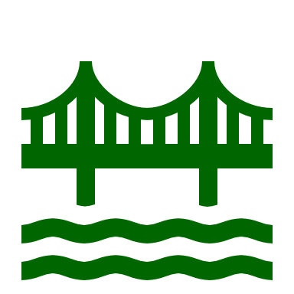  Human processes/features | 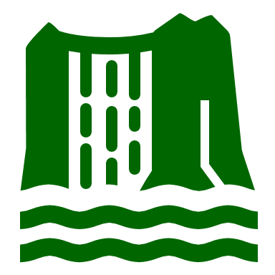    Physical processes/features  Culture  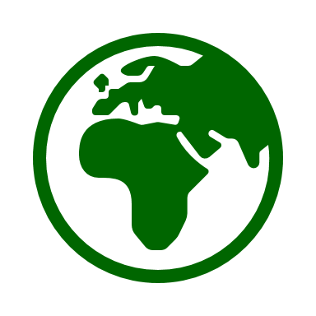    Comparison  Location | Name, locate and identify characteristics of the four countries and capital cities of the United Kingdom and its surrounding seas  Identify seasonal and daily weather patterns in the United Kingdom  Use basic geographical vocabulary to refer to: key physical features, including: beach, cliff, coast, forest, hill, mountain, sea, ocean, river, soil, valley, vegetation, season and weather key human features, including: city, town, village, factory, farm, house, office, port, harbour and shop  use world maps, atlases and globes to identify the United Kingdom and its countries  use aerial photographs and plan perspectives to recognise landmarks and basic human and physical features; devise a simple map; and use and construct basic symbols in a key | To identify seasonal and daily weather patterns in the United Kingdom  To name, locate and identify characteristics of the four countries and capital cities of the United Kingdom and its surrounding seas.  To identify seasonal and daily weather patterns in the United Kingdom | North/ south  Weather, seasonal,  Equator, key physical features, including: beach, cliff, coast, forest, hill, mountain, sea, ocean, river, soil, valley, vegetation, season and weather key human features, including: city, town, village, factory, farm, house, office, port, harbour and shop, map, atlas, UK,

 | Core Knowledge: Topic Three | Threads | NC objectives | Skills | Vocab
Y2 | Geography Detectives: Our Wonderful World  To know the names of the 4 UK countries and the capital cities (re-cap from Year 1)  To know the seven continents and the five oceans  To know where the Equator is  To know where the North and South Poles are  To know the seasonal and daily weather patterns of hot and cold areas of the world in relation to the Equator and the North and South Poles  To know what a compass is and to know simple compass directions  To know what an aerial photograph is  To know what a map is and what simple map symbols are | Comparison  Culture  Physical processes/features  Human processes/features  Location | Name and locate the world’s seven continents and five oceans  Identify seasonal and daily weather patterns and the location of hot and cold areas of the world in relation to the Equator and the North and South Poles  Use world maps, atlases and globes to identify the United Kingdom and its countries, as well as the countries, continents and oceans studied at this key stage  Use simple compass directions (North, South, East and West) and locational and directional language [for example, near and far; left and right], to describe the location of features and routes on a map  Use aerial photographs and plan perspectives to recognise landmarks and basic human and physical features; devise a simple map; and use and construct basic symbols in a key | To name and locate the four countries and capital cities of the UK (recap from Y1)  To name and locate the seas surround the UK countries  (recap from Y1)  To use a compass alongside positional language to describe the location of feature and routes on a map.  To locate the equator on a world map  To identify seasonal and daily weather patterns in the North and South Poles  To use world maps, atlases and globes to identify Europe and surrounding oceans  To use aerial photographs and plan perspectives to recognise landmarks and basic human and physical features; devise a simple map; and use and construct basic symbols in a key | Country, continent, city, ocean, equator, north/ south poles, seasonal, weather patterns, compass, maps, atlases, landmarks, human and physical features, North, South, East, West
 | Core Knowledge: Topic Three | Threads | NC objectives | Skills | Vocab
Y2 | Many Worlds One Planet: Africa  To know where Africa is on a map  To know that Africa is a continent  To know the seasonal and daily patterns  To know the location in relation to the Equator and the North and South Poles  To know the environmental regions, key physical and human characteristics, countries, and major cities  To know the countries and major cities within the continent of Africa and key topographical features (including hills, mountains, coasts and rivers)  To know the geographical similarities and differences through the study of human and physical geography of the United Kingdom, a region in an African Country; including population, climate and the water cycle, food and water  To know the 4 points of a compass |   Culture  Physical processes/features  Human processes/features  Climate  Comparison  Location | understand geographical similarities and differences through studying the human and physical geography of a small area of the United Kingdom, and of a small area in a contrasting non-European country  use world maps, atlases and globes to identify continents and oceans studied at this key stage  use simple compass directions (North, South, East and West) and locational and directional language [for example, near and far; left and right], to describe the location of features and routes on a map  identify seasonal and daily weather patterns and the location of hot and cold areas of the world in relation to the Equator and the North and South Poles  use aerial photographs and plan perspectives to recognise landmarks and basic human and physical features; devise a simple map; and use and construct basic symbols in a key | Use world maps, atlases and globes to identify Africa and surrounding oceans  To be able to compare Africa with a small area of the UK  Name and locate countries and major cities within the continent of Africa and key topographical features (including hills, mountains, coasts and rivers)  To be able to identify human and physical geography of Africa  To be able to identify the seasons and weather in Africa  To be able to identify the Equator, North and South Poles on a map and atlas  To be able to use the 4 points of a compass | Africa, continent, regions, human and physical features, population, climate, compass, Equator, North and South Poles

 | Core Knowledge: Topic Two | Threads | NC objectives | Skills | Vocabulary
Y3 | Many Worlds One Planet: Europe  Know the names and location of the 4 UK countries and their capital cities  Know the names and location of the main counties and cities of England  Know the human and physical characteristics of the UK  Know the names and locations of the continents and the major countries of the world.  Know the seven wonders of the world- Names and locations (human and physical characteristics)  To know the name and location of Greece (including Athens) |   Comparison  Human processes/features  Culture  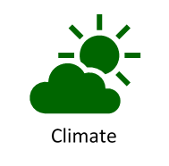 | Name and locate counties and cities of the United Kingdom, geographical regions and their identifying human and physical characteristics, key topographical features (including hills, mountains, coasts and rivers), and land-use patterns; and understand how some of these aspects have changed over time  Locate the world’s countries, using maps to focus on Europe (including the location of Russia) and North and South America, concentrating on their environmental regions, key physical and human characteristics, countries, and major cities  use maps, atlases, globes and digital/computer mapping to locate countries and describe features studied | To use atlases, locate continents and major countries of the world, the UK (and its capital cities and counties)  To identify human and physical characteristics of the UK.  To identify human and physical features of the world.  To name and locate the world’s seven continents and five oceans.  To understand geographical similarities and differences through studying the human and physical geography of a small area of Europe.  To locate Greece on a map | Location, country, continent, counties, physical, human, features/ characteristics, atlas, globe, map, Europe, climate, locate, region

 | Core Knowledge: Topic Three | Threads | NC objectives | Skills | Vocab
Y3 | Geography Detectives: Rivers, Rock and Rubble  To know the names of major rivers in the UK  To know the location of major rivers in the UK  To know the name of the seas that the rivers flow into  To know some of the advantages and disadvantages of rivers  To know what a meander is  To know how rivers have changed over time and what causes this to happen  To know the names of the three different types of rock  To know where the three types of rock are found and how they are formed  To know some of the properties of the three types of rock  To know how to observe and record physical features in the local area |   Field work  Comparison  Physical processes  Climate | Name and locate counties and cities of the United Kingdom, geographical regions and their identifying human and physical characteristics, key topographical features (including hills, mountains, coasts and rivers), and land-use patterns; and understand how some of these aspects have changed over time  Describe and understand key aspects of: physical geography, including: climate zones, biomes and vegetation belts, rivers, mountains, volcanoes and earthquakes, and the water cycle  Use fieldwork to observe, measure, record and present the human and physical features in the local area using a range of methods, including sketch maps, plans and graphs, and digital technologies. | To identify and locate rivers on a map  To be able to follow a river on a map to find where it starts and ends.  To identify meanders on a map  To be able to identify and explain how some rivers have changed  To be able to identify the properties of different types of rocks and to sort accordingly  To be able to carry out fieldwork in the local area | Rivers, location, meander, source, mouth, igneous, sedimentary, metamorphic, formation, volcano, Erodes, riverbank,
 | Core Knowledge: Topic Three | Threads | NC objectives | Skills | Vocab
Y4 | Many Worlds One Planet: The Amazon  Know the Amazon river begins in the Andes Mountains and flows to the Atlantic Ocean.  Know that The Amazon river and its tributaries flow through many counties  Know the different layers of the rainforest  Know that The Amazon river is thought to be at least 6,400km long and the second longest in the world.  Know that the Amazon River flows through The Amazon Rainforest.  Know The Amazon rainforest approximately 6.7 million square kilometres which makes it the largest remaining tropical rainforest in the world.  Know The Amazon Rainforest is home to  40 00- plant species and 2.5 million insect species.  The Amazon rainforest is home  to 10% of the world's known biodiversity  Know that the Amazon Rainforest produces 20% of the world’s oxygen.  To know the climate of the Amazon rainforest  To know about deforestation | 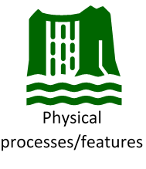  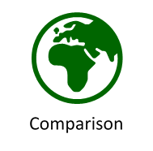  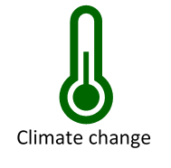 | locate the world’s countries, using maps to focus on Europe (including the location of Russia) and North and South America, concentrating on their environmental regions, key physical and human characteristics, countries, and major cities  identify the position and significance of latitude, longitude, Equator, Northern Hemisphere, Southern Hemisphere, the Tropics of Cancer and Capricorn, Arctic and Antarctic Circle, the Prime/Greenwich Meridian and time zones (including day and night)  describe and understand key aspects of:  ▪ physical geography, including: climate zones, biomes and vegetation belts, rivers,  mountains, volcanoes and earthquakes, and the water cycle | To use maps, atlases, globes and digital computer mapping to name and locate the equator, northern hemisphere, southern hemisphere, the tropics and different rainforests around the world  To describe key aspects of physical geography within the rainforest (layers and biodiversity)  To use a range of sources to identify the key human features of a location  To locate world’s countries (South America), environmental regions, key physical and human characteristics, countries, major cities, vegetation belts, climate zones and biomes on a map (compare sustainability levels between South America and England).  To understand geographical similarities and differences  To know about deforestation and the effects on the environment | Andes Mountains, Atlantic Ocean, tributaries, biome, tropical rainforest, species, biodiversity, humid, tropical, climate, emergent layer, canopy layer, understorey, forest floor, deforestation

 | Core Knowledge: Topic Three | Threads | NC objectives | Skills | Vocab
Y4 | Many Worlds One Planet: USA  To know that North America is the 3rd largest continent and it is made up of 23 countries  To know that North America is in the northern hemisphere  To know the difference between North and South America  To know that USA is in North America  To know that the USA has 50 states  To know some key landmarks in the USA and which state they are in (Statue of Liberty, Washington Monument, Golden Gate Bridge, Mount Rushmore, The White House)  To know where the Grand Canyon is and to know how it was formed. To know the climate and wildlife in the Grand Canyon  To know where Niagara Falls are. To know how they were formed. To know the economic use of the falls (hydropower plant) | Physical processes/features  Climate  Human processes/features  Culture  Location | locate the world’s countries, using maps to focus on Europe (including the location of Russia) and North and South America, concentrating on their environmental regions, key physical and human characteristics, countries, and major cities  identify the position and significance of latitude, longitude, Equator, Northern Hemisphere, Southern Hemisphere  understand geographical similarities and differences through the study of human and physical geography of a region of the United Kingdom, a region in a European country, and a region within North or South America  physical geography, including: climate zones, biomes and vegetation belts, rivers, mountains, volcanoes and earthquakes, and the water cycle  human geography, including: types of settlement and land use, economic activity including trade links, and the distribution of natural resources including energy, food, minerals and water  use maps, atlases, globes and digital/computer mapping to locate countries and describe features studied  use the eight points of a compass, four and six-figure grid references, symbols and key | To locate the world’s countries, using maps to focus on North and South America, concentrating on their environmental regions, key physical and human characteristics, countries, and major cities  To name and locate countries and major cities within the continents of North and South America and key topographical features  To use maps, atlases, globes and digital/computer mapping to locate North and South America with a focus on the USA  To use the eight points of a compass, four and six-figure grid references, symbols and key  To use recognised symbols to mark out local areas of interest on own maps. - Choose effective recording and presentation methods e.g. tables to collect data. | Continent, hemisphere, equator, states, canyon, waterfalls, plunges, hydropower, source, glaciers, valley, erosion,

 | Core Knowledge: Topic Three | Threads | NC objectives | Skills | Vocab
Y5 | Many Worlds One Planet: Antarctica  To know Antarctica is the southernmost continent in the world and contains the South Pole.  To know it has no countries and its population is zero.  To know the climate in Antarctica  To know the size of Antarctica changes with the seasons  To know very few living things live in Antarctica all year.  To know what climate change is  To know the affect of climate change in Antarctica  To know some of the physical features of Antarctica (Transantarctic mountain range, Arctandes, Sentinel range, Meltwater rivers) | 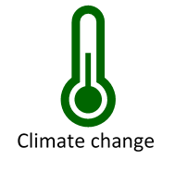  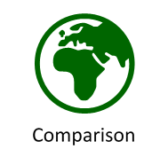 | identify the position and significance of latitude, longitude, Equator, Northern Hemisphere, Southern Hemisphere, the Tropics of Cancer and Capricorn, Arctic and Antarctic Circle, the Prime/Greenwich Meridian and time zones (including day and night)  physical geography, including: climate zones, biomes and vegetation belts, rivers, mountains, volcanoes and earthquakes, and the water cycle  use fieldwork to observe, measure, record and present the human and physical features in the local area using a range of methods, including sketch maps, plans and graphs, and digital technologies. | To be able to locate Antarctica on a world map and identify its position in relation to the equator, Northern Hemisphere, Southern Hemisphere, the Tropics of Cancer and Capricorn, Arctic and Antarctic Circle  To be able to explain the physical geography of Antarctica  To be able to explain what climate change is and how it is affecting Antarctica  To be able to use fieldwork to observe the physical features of Antarctica | population distribution,  meltwater, latitude, longitude,  Greenwich Meridian
 | Core Knowledge: Topic Three | Threads | NC objectives | Skills | Vocab
Y5 | Geography Detectives: Volatile Earth  To know the layers of the earth  To know what tectonic plates are  To know what a volcano is and how they are formed  To know the layers of a volcano  To know what causes a volcano to erupt  To know the 3 types of rock  To know what lava and magma are  To know where the major volcanoes in the world are  To know the key aspects of earthquakes  To know how scientists measure earthquakes (Seismography, Richter scale, Moment Magnitude)  To know what an ‘epicenter’ is  To know some of the countries where earthquakes have happened | 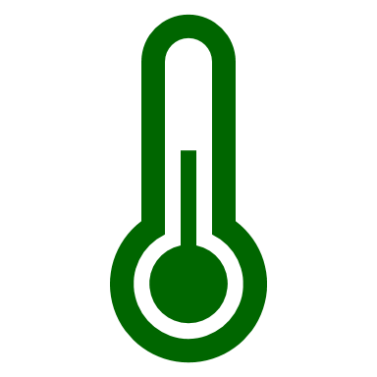  Climate  Field work  Climate change  Physical processes/features | describe and understand key aspects of: physical geography, including: climate zones, biomes and vegetation belts, rivers, mountains, volcanoes and earthquakes, and the water cycle  use maps, atlases, globes and digital/computer mapping to locate countries and describe features studied  use the eight points of a compass, four and six-figure grid references, symbols and key (including the use of Ordnance Survey maps) to build their knowledge of the United Kingdom and the wider world  use fieldwork to observe, measure, record and present the human and physical features in the local area using a range of methods, including sketch maps, plans and graphs, and digital technologies. | To be able to name layers of the earth  To use maps, atlases, globes and digital/computer mapping to locate volcanoes  To be able to describe how volcanoes are formed and what causes them to erupt  To be able to use the eight points of a compass and six- figure refences, symbols and key when locating counties which have a volcano or where earthquakes have occurred  To be able to describe how magma is formed  To be able to use Seismographs, Richter scale, Moment Magnitude to observe and record data | Tectonic plates, crust, mantle, core, magnitude, magma, solidified, lava, seismograph, igneous, sedimentary, metamorphic, formation, erupt, shockwaves, Richter scale, tremor, epicenter
 | Core Knowledge: Topic Three | Threads | NC objectives | Skills | Vocab
Y6 | Many Worlds One Planet: Asia  Know Asia is one of the world’s seven continents and know its location on the world map.  Know it is the biggest continent by area and also has the largest population  Know that Asia is made up of 48 countries.  Know the names of the main countries and their location on a world map  Know a biome is an area with a distinctive climate and vegetation.  Know the different Biomes found in Asia: Gobi Desert, Temperate Grasslands, Coniferous Forests, Tropical Rainforests, Tundra, Himalayas, Mount Everest | Comparison  Climate  Human processes/features  Culture  Physical processes/features  Location | identify the position and significance of latitude, longitude, Equator, Northern Hemisphere, Southern Hemisphere, the Tropics of Cancer and Capricorn, Arctic and Antarctic Circle, the Prime/Greenwich Meridian and time zones (including day and night)  describe and understand key aspects of:  physical geography, including: climate zones, biomes and vegetation belts, rivers,  mountains, volcanoes and earthquakes, and the water cycle  human geography, including: types of settlement and land use, economic activity  including trade links, and the distribution of natural resources including energy,  food, minerals and water  use maps, atlases, globes and digital/computer mapping to locate countries and  describe features studied | To be able to label Asia on a world map  To be able to label some of Asia’s countries on a world map  To be able to locate the Equator, Northern Hemisphere, Southern Hemisphere, the Tropics of Cancer and Capricorn  To be able to explain the physical geography of Asia  To be able to explain the human geography of Asia  To describe and understand biomes | Continent, biome, climate, vegetation, temperate grasslands, shrubland, plains, steppes, coniferous, tundra, permafrost

 | Core Knowledge: Topic Three | Threads | NC objectives | Skills | Vocab
Y6 | Geography Detectives: A Planet Under Threat  Know that equator is an imaginary line around the middle of the Earth.  Know that climate change (global warming) is the process of the planet heating up  Know that climate change is already having huge impacts across the planet for people and wildlife.  Know that The Earth’s climate is getting warmer because of human activity.  Know that humans burn fossils fuels like coal, oil and natural gas for energy and greenhouse gases are released into the atmosphere.  Know that humans also cut down trees across our planet to make space for things like farming and expanding cities.  Know that Greenhouse gases keep our planet warm.  Know that climate change is causing more extreme weather events.  Know what we can do to reduce the amount of greenhouse gas emissions | Field work  Climate change  Climate  Physical processes/features | describe and understand key aspects of: physical geography, including: climate zones, biomes and vegetation belts, rivers, mountains, volcanoes and earthquakes, and the water cycle : human geography, including: types of settlement and land use, economic activity including trade links, and the distribution of natural resources including energy, food, minerals and water  use maps, atlases, globes and digital/computer mapping to locate countries and describe features studied  use the eight points of a compass, four and six-figure grid references, symbols and key (including the use of Ordnance Survey maps) to build their knowledge of the United Kingdom and the wider world  use fieldwork to observe, measure, record and present the human and physical features in the local area using a range of methods, including sketch maps, plans and graphs, and digital technologies. | To be able to identify climate zones  To be able to explain the impact of climate change on the earth  To use digital/computer mapping to observe the affects of climate change  To be able to explain the impact of greenhouse gases  To use fieldwork to observe and record the changes of the physical features due to climate change  To be able to explain why deforestation happens and the impact of this  To be able to explain what we can do to reduce the amount of greenhouse gas emissions | Climate equator climate change global warming fossil fuels greenhouse gases emissions carbon dioxide atmosphere heatwave drought

